# Direct Series Setup

1. The Direct Series Configurator allows us to automatically see what options are on each Direct Series machine. With the addition of the “Program Creation” page to the Direct Series Configurator an entire program would be created, and saved on the server with a press of a button.

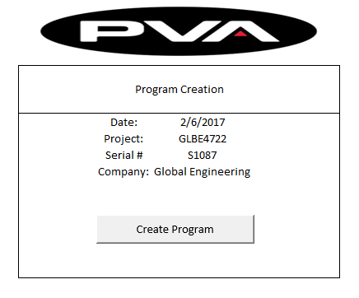

1. Addition of Option Specific Tags in Direct Series Template and Configuration files allows for automatic Code Generation. The addition of these Option Specific Tags allows us to automatically insert or remove code from any file based on which options are selected in the Direct Series Configurator. We are able to not only add single lines, but entire Module (option) templates. In this case we can add or remove our flow monitor code.

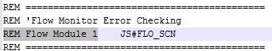Before After



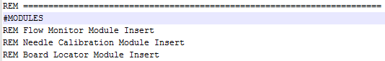

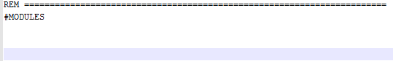

1. 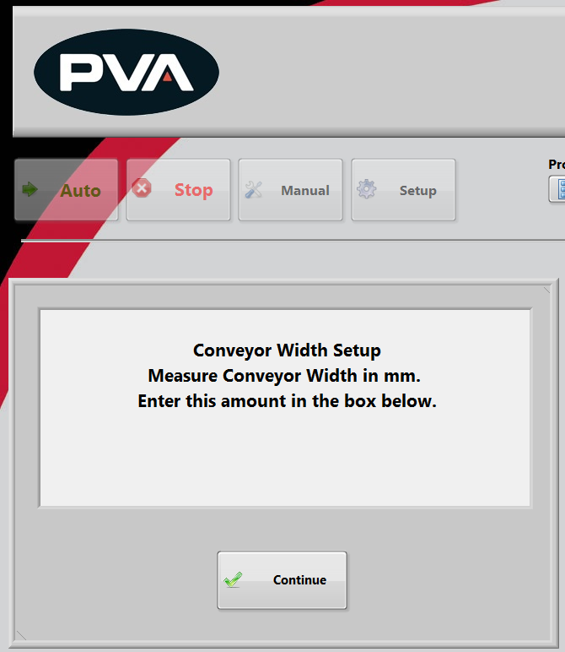Upon initial startup, PVA Portal would guide the user through any additional hardware setup needed on the machine. This step by step procedure would ensure anyone would be equipped to setup all hardware on the machine.

# Development Plan

1. Proof of Concept

Testing has already been completed on implementation of a Direct Series Template with the ability to Add/Remove Pin Locators. We were able to successfully mine data from the configurator, and then create a working main template in the correct dated folder on the server.

1. Prioritize Top Selling Options

We have already reached out to receive information about the sale of 2016 Direct Series Machines. We will use this information to make our decision about what options to develop first, and which less popular options can wait.

1. Coding

We will be breaking the project down into several smaller assignments, each with varying difficulty levels. This will allow us to assign a larger percentage of our team to tasks that will help push the project forward. This will allow us to more easily assign programmers to this project without disrupting the current flow of machines.

1. Testing

Testing will be a combination of using machines that are available for us (Apps Lab, Test Machines), and using new Direct Series Orders. Since the coding will be done in small assignments, these assignments will not need to be tested on Direct Series machines, instead we will only need machines with the correct hardware.

# Requirements/Challenges

1. Software Updates (Portal Pathmaster)

Anytime there is a software update we will need to have advanced notice, and time with the software to implement/test any changes that may be needed.

1. Direct Series Options

Anytime there is a change in which options are offered on a Direct Series we will need time to create and test an update to support it.

1. Direct Series Configurator Updates

Anytime there is an update to the configurator we will need time to update and test our “Code Generation Tool.” We are currently looking in specific locations, for specific information. If this information is moved we will have to update our code as well.

1. Direct Series Additions

If a machine does not meet the requirements of a direct series a programmer will still need to be assigned to the project. Our “Code Generation Tool” does not support Direct Series Plus machines.

1. Machine I/O

It is currently unclear to us how the I/O packages are generated. If there are only a few packages we will be able to support this through the configurator. If I/O packages are created on a need by basis we will find a way for the operator to assign I/O.